- Copyright for test papers and marking guides remains with West Australian Test Papers.
- The papers may only be reproduced within the purchasing school according to the advertised conditions of sale.
- Test papers must be withdrawn after use and stored securely in the school until Wednesday 1st July 2015.

CHEMISTRY
UNIT 1
2015

Name: _________________________________________________________________________________________

Teacher: ________________________________________________________________________________________

TIME ALLOWED FOR THIS PAPER

Reading time before commencing work: Ten minutes
Working time for the paper: Three hours

MATERIALS REQUIRED/RECOMMENDED FOR THIS PAPER

To be provided by the supervisor:
- This Question/Answer Booklet
- Multiple-choice Answer Sheet
- Chemistry Data Sheet

To be provided by the candidate:
Standard items: pens (blue/black preferred), pencils (including coloured), sharpener,
eraser, correction tape/fluid, ruler, highlighters

Special items: non-programmable calculators approved for use in the WACE
examinations

IMPORTANT NOTE TO CANDIDATES

No other items may be taken into the examination room. It is your responsibility to ensure that you do not have any unauthorised notes or other items of a non-personal nature in the examination room. If you have any unauthorised material with you, hand it to the supervisor before reading any further.
Structure of this paper

Section | Number of questions available | Number of questions to be answered | Suggested working time  (minutes) | Marks available | Percentage of exam
Section One:  Multiple-choice | 25 | 25 | 50 | /50 | /25
Section Two:  Short answer | 14 | 14 | 60 | /70 | /35
Section Three:  Extended answer | 5 | 5 | 70 | /80 | /40
 |  |  |  |  | /100

Instructions to candidates

1. Answer the questions according to the following instructions.

Section One: Answer all questions on the separate Multiple-choice Answer Sheet provided. For each questions shade the box to indicate your answer. Use only a blue or black pen to shade the boxes. If you make a mistake, place a cross through that square then shade your new answer. Do not erase or use correction fluid/tape. Marks will not be deducted for incorrect answers. No marks will be given if more than one answer is completed for any question.

Sections Two and Three: Write your answers in this Question/Answer Booklet.

2. When calculating numerical answers, show your working or reasoning clearly. Express numerical answers to three significant figures and include appropriate units where applicable.

3. You must be careful to confine your responses to the specific questions asked and to follow any instructions that are specific to a particular question.

4. Spare pages are included at the end of this booklet. They can be used for planning your responses and/or as additional space if required to continue an answer.
  - Planning: If you use the spare pages for planning, indicate this clearly at the top of the page.
  - Continuing an answer: If you need to use the space to continue an answer, indicate in the original answer space where the answer is continued, i.e. give the page number. Fill in the number of the question(s) that you are continuing to answer at the top of the page.
PART 1 - MULTIPLE CHOICE [50 MARKS – 25%]

Section One: Multiple-choice 25% (50 marks)

This section has 25 questions. Answer all questions on the separate Multiple-choice Answer Sheet provided. For each question, shade the box to indicate your answer. Use only a blue or black pen to shade the boxes. If you make a mistake, place a cross through that square then shade your new answer. Do not erase or use correction fluid/tape. Marks will not be deducted for incorrect answers. No marks will be given if more than one answer is completed for any question.

Suggested working time: 50 minutes.

- Which element does NOT form ions with the same electron configuration as argon?

  - S
  - Ca
  - Aℓ
  - Cℓ

- Using the given coefficients, balance the unbalanced equation below:

… Na₃PO₄(aq) + … CaCℓ₂(aq) … NaCℓ(aq) + … Ca₃(PO₄)₂(s)

  - 1, 3, 3, 1
  - 2, 3, 3, 2
  - 2, 3, 6, 1
  - 2, 3, 3, 1

- A metal (X) ion combines with the oxide ion to form an ionic compound with the formula X₂O₃. Which of the following is the most likely formula when X combines with the nitride ion?

  - X₂N₃
  - XN
  - X₃N₂
  - XN₃

- Which of the following compounds has a bonding structure which differs from the other three?

  - Na₂SO₄
  - RbOH
  - NH₄Cℓ
  - SiO₂
- In which of the following molecules would you find six electrons shared between two bonding atoms?

  - Oxygen gas
  - Ethane gas
  - Ammonia gas
  - Nitrogen gas

- Electronegativity tends to increase as:

  - You go down a group of the periodic table
  - You go from left to right across a period of the periodic table
  - The atomic number increases
  - The valency of the common ion increases

- Which of the following statements is the best definition of ionisation energy?

  - It is the energy needed to change a mole of a substance from a liquid to a gas
  - It is the energy required to dissociate one mole of ions in the solid phase
  - It is the energy required to remove a mole of electrons from a mole of atoms or ions of an element in the gas phase
  - It is the energy required to form one mole of an ionic substance from its constituent atoms

- The gold foil experiment was conducted by Ernest Rutherford. What information did this experiment provide Rutherford about the internal structure of atoms?

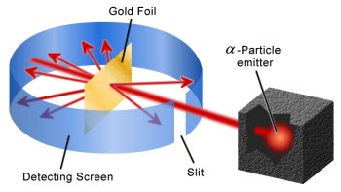
  - Atoms contain small positively charged particles
  - Atoms contain small negatively charged particles
  - Electrons exist in discrete energy levels
  - The positive charge of an atom is concentrated in the nucleus

- The periodic table arranges elements into periods and groups. What is the main criteria used to order elements within a period?

  - Increasing atomic number
  - Number of valence electrons
  - Number of electron shells filled
  - Increasing mass number

- The emission spectra produced by four different elements are shown below.
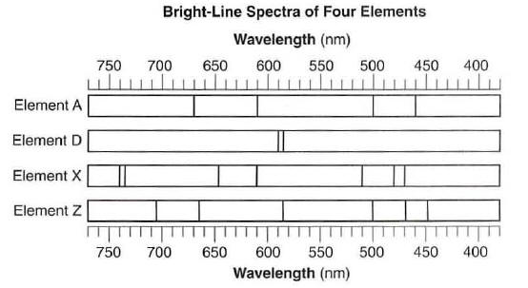

The following spectrum is produced from a mixture containing two of the above elements.

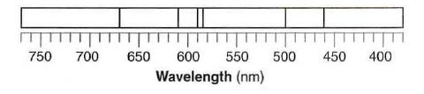

Which elements are present in the mixture?

  - Elements A and D
  - Elements A and X
  - Elements Z and D
  - Elements Z and X

- Why does each element emit multiple wavelengths of light?

  - There are many ground states in an atom
  - Atoms can release multiple photons at once
  - There are different isotopes of each element
  - There are many excited states in an atom

- Mass spectrometers separate isotopes of different elements based on their:

  - Mass only
  - Electric charge only
  - Mass and electric charge
  - Wavelength of photons

- Which of the following substances has a combination of covalent and ionic bonding?

  - CsF(s)
  - Ca₃(PO₄)₂(s)
  - HF(g)
  - C(s) (graphite)

- Which of the following calculations correctly shows the percentage of carbon in one molecule of ethane?

(a) | $$\%C= \frac{12.01}{12.01×2+1.008×4}=42.8\%$$
(b) | $$\%C= \frac{12.01×2}{12.01×2+1.008×4}=85.6\%$$
(c) | $$\%C= \frac{12.01}{12.01×2+1.008×6}=39.9\%$$
(d) | $$\%C= \frac{12.01×2}{12.01×2+1.008×6}=79.9\%$$

- Which of the following is always produced during combustion of fossil fuels?

  - Water
  - Carbon (soot)
  - Sulfur dioxide
  - Carbon monoxide

- Iodine readily sublimes from solid to gas when moderately heated. Which of the following options correctly describes the nature of iodine particles in the solid and gaseous phases?

 | Structure of solid iodine | Structure of gaseous iodine
(a) | Ionic network | Individual atoms
(b) | Ionic network | Discrete molecules
(c) | Discrete molecules | Individual atoms
(d) | Discrete molecules | Discrete molecules

- What distinguishes pure substances from mixtures?

  - Pure substances have more than one type of atom in a fixed ratio
  - Pure substances are homogeneous in nature
  - Pure substances are made of one type of atom only
  - Pure substances have fixed chemical and physical properties

- What is the correct IUPAC name for the following compound?

CH₃–CH₂–CH₂–CH–CH₂–Cℓ
|
CH₃

  - 5-chloro-4-methylpentane
  - 4-methyl-5-chloropentane
  - 1-chloro-2-methylpentane
  - 2-methyl-1-chloropentane

- Which of the following compounds readily undergoes addition reactions?

  - Ethane
  - Benzene
  - Propene
  - Tetrachloromethane

- When ethene gas is reacted with bromine water, which of the following gives the correct product or products?

  - bromoethane and hydrogen bromide
  - 1,1-dibromoethane
  - 1,2-dibromoethane
  - hexabromoethene

- The enthalpy of combustion of methane (CH₄) is -882 kJ mol⁻¹. What mass of methane would be needed to be burned to produce 88.2 kJ of energy?

  - 1.6 g
  - 16 g
  - 88.2 g
  - 882 g

- Which one of the following substances conducts electricity due to the movement of oppositely charged ions?

  - Aluminium metal
  - Graphite
  - Solid zinc chloride
  - Molten sodium chloride

- Propane is commonly used as a fuel for portable stoves. It combusts with oxygen to produce carbon dioxide and water. The reaction is commonly represented as:

C₃H₈(g) + 5O₂(g) 3CO₂(g) + 4H₂O(g)

Which of the following alternatives accurately represents a correct mole relationship for the above reaction?

(a) | $$n\left({CO}_{2}\right)=\frac{5}{3} × n\left(O_{2}\right)$$
(b) | $$n\left(H_{2}O\right)=\frac{5}{4} × n\left(O_{2}\right)$$
(c) | $$n\left({CO}_{2}\right)=\frac{3}{5} × n\left(O_{2}\right)$$
(d) | $$n\left(H_{2}O\right)=\frac{3}{4} × n\left({CO}_{2}\right)$$

- When magnesium is heated in the presence of oxygen it emits a bright light. What term can be used to describe this reaction?

  - Exothermic
  - Endothermic
  - Empirical
  - Spontaneous

- Which of the following hydrocarbons has NOT been named correctly?

  - ethylpentane
  - 2-ethylbutane
  - 2,2-dimethylbutane
  - 2,3-dimethylbutane

PART 2 - SHORT ANSWER [70 marks – 35%]

This section has 14 questions. Answer all questions. Write your answers in the spaces provided.

When calculating numerical answers, show your working or reasoning clearly. Express numerical answers to three significant figures and include appropriate units where applicable.

Spare pages are included at the end of this booklet. They can be used for planning your responses and/or as additional space if required to continue an answer.
- Planning: If you use the spare pages for planning, indicate this clearly at the top of the page.
- Continuing an answer: If you need to use the space to continue an answer, indicate in the original answer space where the answer is continued, i.e. give the page number. Fill in the number of the question(s) that you are continuing to answer at the top of the page.

Suggested working time: 60 minutes.

- (4 marks)

- Write the formulas of the following compounds:

Answer | Marks
- CBr₂F₂ | 0.5 marks
- H₂SO₄ | 0.5 marks
- Mg(OH)₂ | 0.5 marks
- NH₃ | 0.5 marks
Total marks: | 2 marks

- Write the names of the following species:

Answer | Marks
- Copper(II) iodide | 0.5 marks
- Dinitrogen monoxide | 0.5 marks
- Sulfite (ion) | 0.5 marks
- Hydrogen peroxide | 0.5 marks
Total marks: | 2 marks

- (8 marks)

Isotopes of carbon are used to determine the age of fossilised organic samples dug up by archaeologists. In particular, analysts would focus on the ratio of carbon-12 atoms to carbon-14 atoms.

- Write the symbol for a carbon-14 atom in the form of ${}_{Z}^{A}X$. (1 mark)

Answer | Marks
$${}_{6}^{14}C$$ | 1 mark
Total marks: | 1 mark

- What is meant by the term isotope? (2 marks)

Answer | Marks
Same number of protons / atomic number | 1 mark
Different number of neutrons / mass number | 1 mark
Total marks: | 2 marks

- Explain why two isotopes of the same element have the same chemical properties.
(2 marks)

Answer | Marks
Properties depend on electrons | 1 mark
Same element = same electron configuration | 1 mark
Total marks: | 2 marks

- Calculate the mass, in grams, of a single atom of carbon-12. Express your answer in scientific notation to three significant figures. (3 marks)

Answer | Marks
$$n\left(C\right)=\frac{N(C)}{6.022×{10}^{23}}=\frac{1}{6.022×{10}^{23}}=6.022×{10}^{-23} mol$$ | 1 mark
$$m\left(C\right)=n×M=6.022×{10}^{-23} ×12.01=7.23×{10}^{-22} g$$ | 1 mark
Gives answer to three significant figures | 1 mark
Total marks: | 3 marks

- (4 marks)

Draw electron-dot diagrams showing the arrangement of valence electrons in the following chemical species. Represent all valence shells as : or –

Ethane (C₂H₆) | Sodium bromide (NaBr)
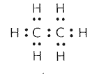 | 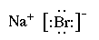

Answer | Marks
Ethane:  - Correct number of covalent bonds  - No lone pairs | 1 mark  1 mark
Sodium bromide:  - Represented as ionic substance (i.e. no shared electrons)  - Correct charges and square brackets included | 1 mark  1 mark
Total marks: | 4 marks

- (5 marks)

Complete the following table.

Substance | Name | Type(s) of bonds
Ti | Titanium | Metallic
CS₂ | Carbon disulphide | Covalent
NH₄Cℓ | Ammonium chloride | Covalent AND ionic
Ne | Neon | None (does not form bonds)
SiO₂ | Silicon dioxide | Covalent

Answer | Marks
Answers as per table above | 0.5 x 10
Total marks: | 5 marks
- (5 marks)

- Using labelled arrows, on the periodic table below clearly label the trends in electronegativity and ionisation energy. (2 mark)

Answer | Marks
Ionisation energy shown to increase from bottom left to top right | 1 mark
Electronegativity shown to increase from bottom left to top right | 1 mark
Total marks: | 5 marks

- The following diagram shows a visual representation of atomic radius sizes. The size of each circle is proportional to the size of each atom.
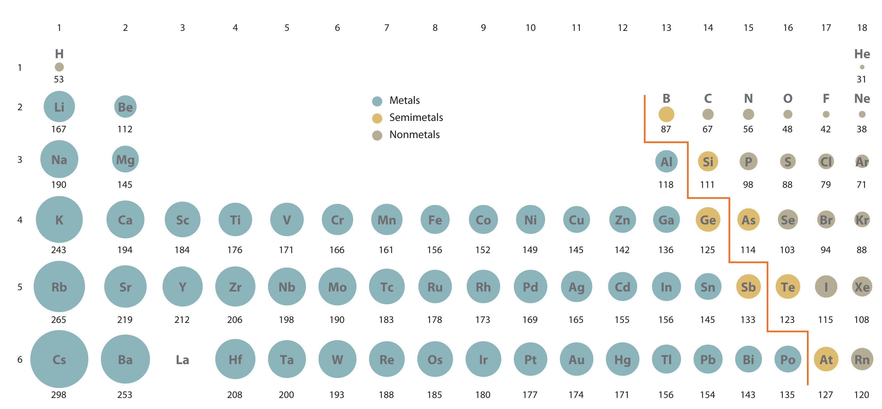

Explain the trend in atomic radius going across a period. (3 marks)

Answer | Marks
Electrons added to same valence shell… | 1 mark
… and more protons in the nucleus… | 1 mark
…therefore stronger attraction between nucleus and valence electrons | 1 mark
Total marks: | 3 marks

- (6 marks)

Diamond and graphite are two allotropes of carbon. Although both are made of carbon atoms, graphite is bonded in a 2D covalent structure whereas diamond is bonded in a 3D covalent structure.

- Circle the correct options in the table to compare the properties of graphite and diamond. (2 mark)

Property | Graphite | Diamond
Melting point | High | High
Electrical conductivity | High | None

Answer | Marks
Answers as per table above | 0.5 x 4
Total marks: | 2 marks

Carbon nanotubes are an example of a nanomaterial. This allotrope of carbon forms cylinders with each carbon atom covalently bonded to three others. The diameter of nanotubes can be as small as 1 nm and can have lengths of up to several centimetres.

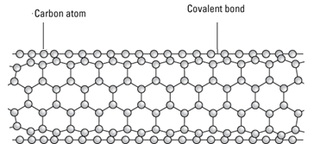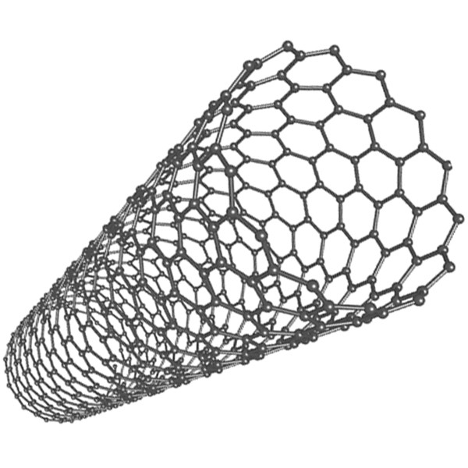

- Using your knowledge of the properties of graphite and diamond, predict the properties of carbon nanotubes. Justify your answer in terms of the structure and nature of bonding in the nanotube. (4 marks)

Answer | Marks
- Conducts electricity  If each carbon is bonded to 3 others then there must be delocalised electrons | 1 mark  1 mark
- Strong  All atoms are joined by strong covalent bonds | 1 mark  1 mark
Total marks: | 4 marks

- (8 marks)

- Draw labelled diagrams showing the difference in structure between silver (a metal) and silver chloride (an ionic substance). (2 marks)

Silver | Silver chloride
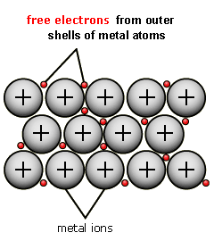 | 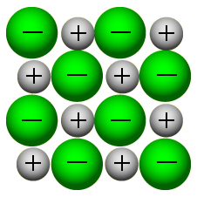

Answer | Marks
Answers as per table above | 1 x 2
Total marks: | 2 marks

- Describe and explain the difference in malleability of silver and silver chloride. (3 marks)

Answer | Marks
Silver is malleable but silver is not (/ is brittle) | 1 mark
Silver atoms can be moved without disrupting/breaking the metallic bond | 1 mark
If a row of Na and Cℓ ions slips then like charges will repel and crystal will shatter | 1 mark
Total marks: | 3 marks

- Describe and explain the difference in electrical conductivity of solid silver and solid silver chloride. (3 marks)

Answer | Marks
Silver conducts but silver chloride does not | 1 mark
Silver: delocalised electrons act as mobile charge carriers | 1 mark
Silver chloride: Charged ions are in fixed positions therefore cannot be mobile charge carriers | 1 mark
Total marks: | 3 marks

- (6 marks)

- Label the following diagram of water molecules to show the location of the covalent bonds and the intermolecular forces. (2 marks)

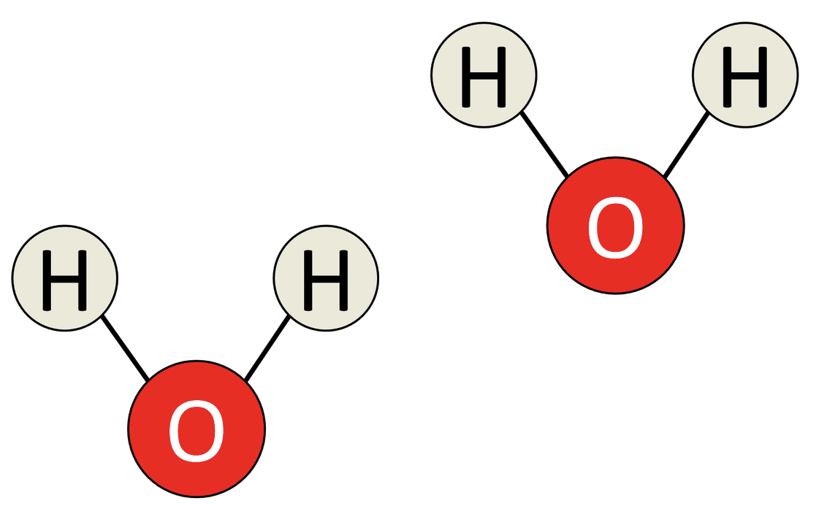

Answer | Marks
Intermolecular forces shown between molecules | 1 mark
Covalent bond shown as the line joining H to O atoms | 1 mark
Total marks: | 2 marks

- All bonds are based on some form of electrostatic attraction. Describe the nature of electrostatic attraction involved in a covalent bond. (1 mark)

Answer | Marks
Attraction between positive nuclei and negative shared electrons | 1 mark
Total marks: | 1 mark

- Using the concept of covalent bonds and intermolecular forces, explain why the melting point of water is so different to the melting point of diamond. (3 marks)

Answer | Marks
Diamond is covalent network whereas H₂O Is covalent molecular | 1 mark
Diamond: Strong covalent bonds join all atoms. Difficult to break therefore high melting point. | 1 mark
Water: Weak intermolecular forces join molecules. Relatively easy to break so low melting point | 1 mark
Total marks: | 3 marks

- (2 marks)

The element gallium has the electron configuration 2, 8, 18, 3. Using the same notation, give the electron configuration of:

Answer | Marks
- 2,8,7 | 1 mark
- 2,8,8 | 1 mark
Total marks: | 2 marks

- (3 marks)

Give IUPAC names for the following organic compounds:

Answer | Marks
- But-1-ene  Also accept: 1-butene | 1 mark
- 4-ethyl-5.5-dimethyloctane  Also accept 5-ethyl-4,4-dimethyloctane | 1 mark
- Ethylbenzene | 1 mark
Total marks: | 3 marks

- (4 marks)

Draw structural diagrams of the two organic compounds named here:

Answer | Marks
- CH₃-C=C-CH₂-CH₃  | |  I CH₃ | 1-2 marks
- CH₃  |  CH₃CH=CHCH₂CHCHCH₂CH₃  |  CH₃ | 1-2 marks
Total marks: | 2 marks

- (3 marks)

For each of the following molecular equations, write an ionic equation which shows the reacting species in each equation. Do not include any spectator ions.

Answer | Marks
Full marks: 2 Ag⁺(aq) + 2 CO₃²⁻(aq) Ag₂CO₃(s) | 2 marks
Award 1 out of 2 if dissolved ionic solutions are written as ions but spectrators are not removed. | -
Total marks: | 2 marks

Answer | Marks
2 Mg(s) + O₂(g) → 2 MgO(s)  (should be identical to original equation) | 1 mark
Total marks: | 1 mark

Write balanced chemical equations for each of the following reactions. Show the structure and give the name of any organic products. (9 marks)

- Methane and chlorine gas react to completion

CH₄ + 4 Cl₂ CCl₄ + 4 HCl

Answer | Marks
Recognises that CCl₄ is produced | 1 mark
Names organic product (“carbon tetrachloride” or “tetrachloromethane”) | 1 mark
Completes and balances rest of equation | 1 mark
Award 1.5 / 3 for a fully correct equation for single substitution (CH₃Cl) | -
Total marks: | 3 marks

- Hydrogen gas is mixed with but-2-ene in the presence of a platinum catalyst

CH₃CH=CHCH₃ + H₂ CH₃CH₂CH₂CH₃

Answer | Marks
Gives structure of product (CH₃CH₂CH₂CH₃) | 1 mark
Names organic product (“butane”) | 1 mark
Completes and balances rest of equation | 1 mark
Total marks: | 3 marks

- A small amount of iodine is added to liquid benzene
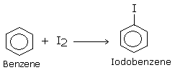
+ HI

Answer | Marks
Correct structure of product | 1 mark
Names organic product (“iodobenzene”) | 1 mark
Completes and balances rest of equation | 1 mark
Total marks: | 3 marks

- (3 marks)

Heptane and hept-1-ene are both colourless liquids which boil between 90 °C and 100 °C. They are soluble in each other and have very similar physical properties.

Describe a chemical test which would allow you to distinguish between a sample of heptane and a sample of hept-1-ene. Your answer should include a description of the test performed and what would be observed when this test is performed with each of the samples.

Answer | Marks
Chemical test:  - Add bromine (Br₂) / iodine (I₂) | 1 mark
Observation with heptane:  - No reaction OR colour slowly fades | 1 mark
Observation with hept-1-ene:  - Colour rapidly fades / Goes colourless | 1 mark
Total marks: | 3 marks

PART 3 – EXTENDED ANSWER [80 marks – 40%]

This section contains five (5) questions. You must answer all questions. Write your answers in the spaces provided below.

Where questions require an explanation and/or description, marks are awarded for the relevant chemical content and also for coherence and clarity of expression. Lists or dot points are unlikely to gain full marks.

Final answers to calculations should be expressed to three significant figures.

Spare pages are included at the end of this booklet. They can be used for planning your responses and/or as additional space if required to continue an answer.
- Planning: If you use the spare pages for planning, indicate this clearly at the top of the page.
- Continuing an answer: If you need to use the space to continue an answer, indicate in the original answer space where the answer is continued, i.e. give the page number. Fill in the number of the question(s) that you are continuing to answer at the top of the page.

Suggested working time: 70 minutes.

- (10 marks)

Saponification (the making of soap) is the hydrolysis of plant oil or an animal fat by treating it with a strong base. Below is a chemical reaction depicting the conversion of a fat molecule (triglyceride) into glycerol and the salt of a fatty acid (soap).

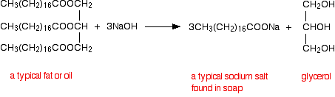
Triglyceride (fat) Salt of fatty acid (soap) + Glycerol

- Give the formula of the triglyceride in the form of C_{x}H_{y}O_{z}. (1 mark)

Answer | Marks
C₅₇H₁₁₀O₆ | 1 mark
Total marks: | 1 mark

- Calculate the molar mass of a triglyceride molecule. (1 mark)

Answer | Marks
M(C₅₇H₁₁₀O₆) = 891.45 g/mol | 1 mark
Total marks: | 1 mark

- If 0.140 moles of triglyceride reacts with an excess of sodium hydroxide, how many moles of the salt of a fatty acid are produced? (1 mark)

Answer | Marks
n(fatty acid) = 3 x n(triglyceride)  = 3 x 0.140  = 0.420 mol | 1 mark
Total marks: | 1 mark

- What is the mass of salt of fatty acid resulting from the breakdown of 0.140 moles of triglyceride? (2 marks)

Answer | Marks
M(fatty acid) = 306.45 g / mol | 1 mark
m(fatty acid) = n x M  = 0.420 x 306.45  = 129 g | 1 mark
Total marks: | 2 marks

- Determine the percentage composition by mass of each element in a triglyceride molecule. (3 marks)

Answer | Marks
%C = 57x12.01 / 891.45 = 76.8% | 1 mark
%H = 110x1.008 / 891.45 = 12.4% | 1 mark
%O = 6x16.00 / 891.45 = 10.8% | 1 mark
Total marks: | 3 marks

- Why is heat required for this reaction to occur? (1 mark)

Answer | Marks
Energy is needed to break covalent bonds | 1 mark
Total marks: | 1 mark

- Is triglyceride an example of a hydrocarbon? Justify your answer. (1 mark)

Answer | Marks
No. It contains oxygen therefore it is not a hydrocarbon. | 1 mark
Total marks: | 1 mark

- (21 marks)

Mercury is highly toxic and is a threat to human health, particularly to young children and pregnant women. Mercury occurs in a number of forms, including elemental (metallic) mercury, inorganic mercury (e.g. mercury chloride) and organic mercury (e.g. methylmercury). Aquatic organisms can acquire high concentrations of mercury through a process known as bioaccumulation.

Atomic absorption spectroscopy (AAS) is one method for analysing the concentration of mercury in soil and fish samples. A schematic figure of an atomic absorption spectrophotometer is shown below:

- In the above diagram, what are the purposes of the following parts? (3 marks)

Answer | Marks
- Emits wavelength of light characteristic to the element being analysed | 1 mark
- Atomises sample / Breaks sample into atoms | 1 mark
- Selects one wavelength of light to be measured | 1 mark
Total marks: | 3 marks

- Complete the graph below to show a calibration curve for mercury. (6 marks)

Linear trend line:

Curved trend line:

Answer | Marks
x-axis label and units | 1 mark
y-axis label | 1 mark
Title | 1 mark
Appropriate scale (starts at 0, regular intervals, take up majority of space) | 1 mark
Data plotted correctly | 1 mark
Linear trend line OR sketched curve trend line | 1 mark
Total marks: | 6 marks

- An analysis of two samples containing mercury was then performed. Use your calibration curve to estimate the concentration of mercury in each sample. (1 mark)

Answer | Marks
Accept answers consistent with students’ graph. Answers may vary  - Sample 1: ~11ppm to ~14ppm  - Sample 2: >25ppm | 2 marks
Total marks: | 2 marks

- Compare the validity of the two estimations you made in part (c). (2 marks)

Answer | Marks
Sample 1 estimate is more valid than sample 2 | 1 mark
…because sample 2 lies outside the calibration range of data (therefore don’t know if trend continues to follow same pattern at 0.90 absorbance) | 1 mark
Total marks: | 2 marks

- Suggest two improvements to the method of this analysis which could improve the reliability of the results. (2 marks)
Answer | Marks
Options include:  - Perform repeated trials (of standards AND/OR of samples)  - Include standards with higher concentrations  - Include more standards (e.g. every 1 ppm instead of every 5 ppm) | 1-2 marks
Total marks: | 2 marks

- Samples analysed by mass spectrometry must first be ionised. Briefly describe how this is achieved in a mass spectrometer. (2 marks)
Answer | Marks
Collisions/Bombardment with high energy electrons… | 1 mark
…turns neutral molecules/atoms into positive ions | 1 mark
Total marks: | 2 marks

- Name the part of the mass spectrometry which deflects the ions after they have been accelerated by an electric field. (1 mark)
Answer | Marks
Electromagnet | 1 mark
Total marks: | 1 mark
Mass spectral analysis of an unknown sample yielded the following mass spectrum, with two elements (A and B) identified.

Element B
Element A

- Determine the relative atomic mass of Element B. You must show all working to obtain full marks. (2 marks)

Answer | Marks
$$\frac{90×51.45 + 94 ×17.38 + 92×17.15 + 91 ×11.22 + 96×2.8 }{100} \\ =91.31$$ | 2 marks
Total marks: | 2 marks
Award 1 out of 2 for mostly correct working with minor mistake(s)

- Identify the two elements present in the mass spectrum. (2 marks)

Answer | Marks
Element A: Carbon | 1 mark
Element B: Zirconium | 1 mark
Total marks: | 2 marks

- (24 marks)

Many of the fuels we use of distilled from crude oil, using an apparatus similar to that shown below:

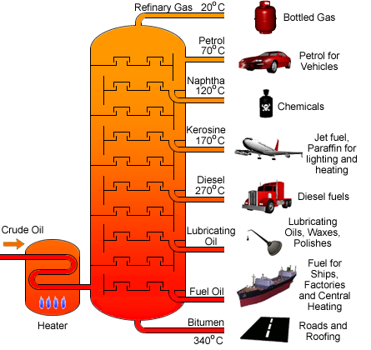

- Give a brief description demonstrating your understanding of what is occurring in the diagram. (2 marks)

Answer | Marks
Heater causes components of crude oil to boil/evaporate/vaporise | 1 mark
Substances cool as they rise and condense into liquids at different parts of the column | 1 mark
Total marks: | 2 marks

- Name the physical property that this separation process is based on. (1 mark)

Answer | Marks
Boiling point | 1 mark
Total marks: | 1 mark

- A typical petro diesel molecule has the molecular formula C₁₆H₃₄. Biodiesel, however, is derived from renewable resources such as vegetable oil or animal fat and has a typical molecular formula C₁₇H₃₄O₂. Assuming complete combustion, write separate balanced equations for the combustion of (i) petro diesel and (ii) biodiesel. (2 marks)

Answer | Marks
- 2 C₁₆H₃₄ + 49 O₂ 32 CO₂ + 34 H₂O | 1 mark
- 2 C₁₇H₃₄O₂ + 49 O₂ 34 CO₂ + 34 H₂O | 1 mark
Total marks: | 2 marks
Award 0.5/2 if CO₂ and H₂O are shown as the products in each equation but students were unable to balance O₂.

- In order to determine the mass of carbon dioxide released from the combustion of 1 tonne of biodiesel (C₁₇C₃₄O₂), first calculate the number of moles of biodiesel in 1 tonne (1000 kg). (3 marks)

Answer | Marks
M(C₁₇H₃₄O₂) = 270.442 g/mol | 1 mark
Converts mass from tonnes into grams (m = 1,000,000 g) | 1 mark
n(C₁₇H₃₄O₂) = 1,000,000 / 270.442 = 3697.7 = 3700 mol | 1 mark
Total marks: | 3 marks

- Determine the number of moles of carbon dioxide released from the combustion of one tonne of biodiesel. (1 mark)

Answer | Marks
n(CO2) = 34 / 2 x n(biodiesel) = 34 / 2 x 3697.7 = 62860 = 62900 mol | 1 mark
Total marks: | 1 mark

- Determine the mass (in tonnes) of carbon dioxide produced from the combustion of 1 tonne of biodiesel. (2 marks)

Answer | Marks
m(CO₂) = n x M = 62900 x 44.01 = 2.77 x 10⁶ g | 1 mark
Converts mass to tonnes (2.77 tonnes) | 1 mark
Total marks: | 2 marks

- What mass of oxygen gas would be required for the combustion of 1 tonne of biodiesel? (3 marks)

Answer | Marks
M(CO₂) = 32.00 g/mol | 1 mark
n(O₂) = 49/2 x n(biodiesel) = 90592 = 90600 mol | 1 mark
m(O₂) = n x M = 90600 x 32.00 = 2.90 x 10⁶ grams  (or 2.90 tonne) | 1 mark
Total marks: | 3 marks

- The heat of reaction is -10,700 kJ/mol for the combustion of petro diesel. Complete the graph below to show the enthalpy change during this reaction. Include appropriate labels on your graph. (5 marks)
ΔH = -10,700 kJ

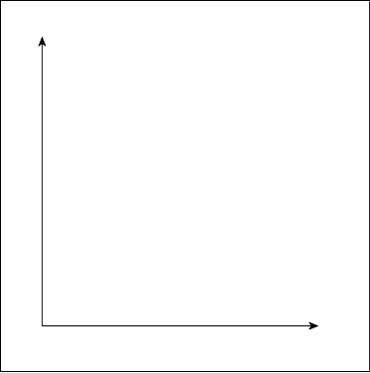
products
reactants
Enthalpy (kJ/mol) OR Enthalpy (kJ)
Reaction progress / Reaction co-ordinate / Time
ΔH = -10,700 kJ

Answer | Marks
x-axis label | 1 mark
y-axis label, including units (either kJ OR kJ/mol) | 1 mark
Exothermic reaction (H_{products} < H_{reactants}) | 1 mark
ΔH is shown and labelled | 1 mark
Size of ΔH is indicated through labels OR a scale on y-axis | 1 mark
Products and reactants labelled (either with words or chemical formulas) | 1 mark
Total marks: | 6 marks
- Given that the heat of reaction for petro diesel is -10,700 kJ/mol, calculate the amount of heat released when 2,000 g of petro diesel (C₁₆H₃₄) undergoes combustion. (3 marks)

Answer | Marks
M(C₁₆H₃₄) = 226.432 g/mol | 1 mark
n(C₁₆H₃₄) = m / M = 2000 / 226.432 = 8.83 mol | 1 mark
Heat released = 10700 kJ/mol x 8.83 mol = 94510 kJ | 1 mark
Total marks: | 3 marks

- List two factors other than CO₂ emissions and energy output that should be considered when comparing the advantages and disadvantages of diesel and biodiesel. (2 marks)

Answer | Marks
Options may include:  - Availability  - Cost  - Sustainability / Renewability  - Carbon monoxide emissions  - Safety | 1-2 marks
Total marks: | 2 marks

- (9 marks)

Esters are a group of organic substances containing carbon, hydrogen and oxygen. They are renowned for their pleasant odours. They are the chemicals often responsible for the smell and taste of bananas, oranges and pineapples.

- For each of the following hydrocarbons, list the molecular formula (in the form of C_{x}H_{y}O_{z}) and the simplified empirical formula. (4 marks)

Name and structural formula | Molecular formula | Empirical formula
pentyl ethanoate:  H₃C–C–O–CH₂–(CH₂)₃–CH₃  ||  O | C₇H₁₄O₂ | C₇H₁₄O₂
methyl salicylate:  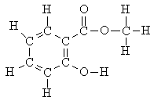 | C₈H₈O₃ | C₈H₈O₃

Answer | Marks
See table above | 4 x 1 mark
Total marks: | 4 marks

The ester ‘ethyl ethanoate’ is produced from the condensation reaction of ethanoic acid and ethanol. An additional molecule is produced as a by-product in this reaction.
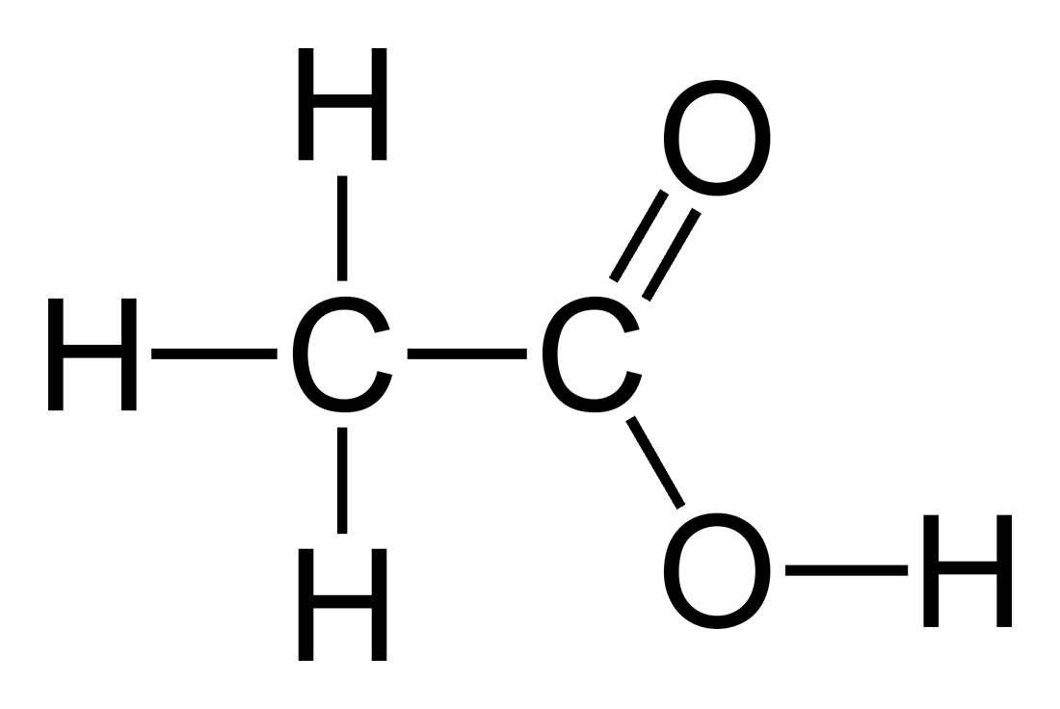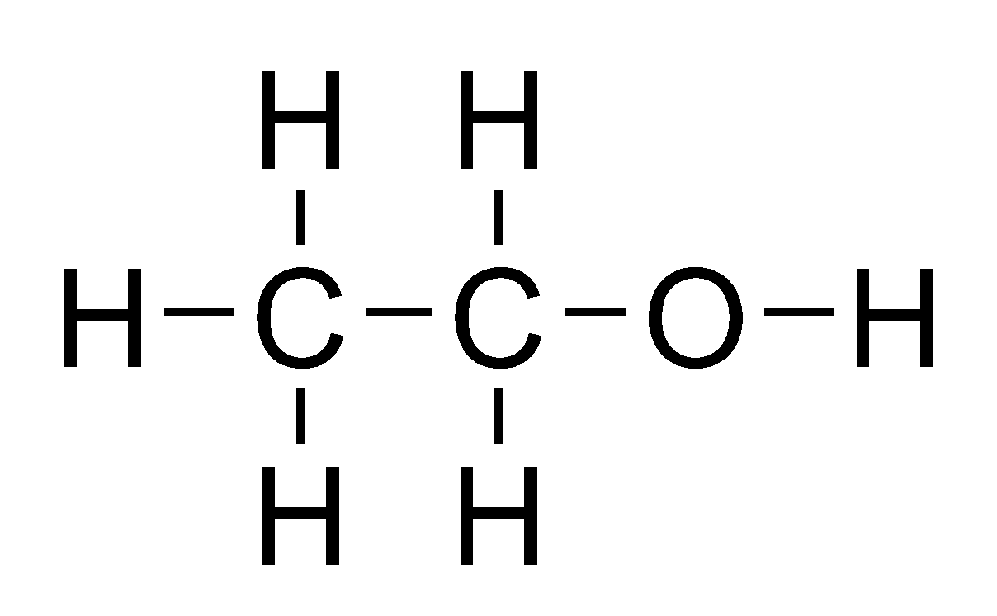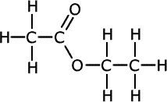
+ …………
⇌
+

Ethanoic acid Ethanol ⇌ Ethyl ethanoate

- Complete the above equation by writing the formula of the by-product. (1 mark)

Answer | Marks
H₂O | 1 mark
Total marks: | 1 mark
- At the end of the reaction there will still remain a mixture of ethanoic acid, ethanol and ethyl ethanoate. The final step in the production of ethyl ethanoate is to separate it from the other reactants.

Substance | Solubility in water | Solubility in hexane | Boiling point
Ethyl ethanoate | Insoluble | Soluble | 77
Ethanol | Soluble | Insoluble | 78
Ethanoic acid | Soluble | Insoluble | 118

Use the information in the above table to propose a method for separating ethyl ethanoate from the other reactants.
- Name your separation method (1 mark)
- Draw a diagram of the separation apparatus (1 mark)
- Briefly explain how your method allows the substances to be separated (2 marks)

Answer | Marks
Separating funnel  (Do not award mark for ‘distillation’ – Boiling points are too close. But do give follow through marks to remaining parts if students have used distillation.) | 1 mark
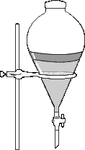 | 1 mark
Mixture is added to a separating funnel and hexane is added.  Ethyl ethanoate will dissolve in the hexane but the other substances will dissolve in the water.  The two layers will be separated because they don’t dissolve in each other. Open the tap to pour out the bottom layer. This will separate the substances. | 1 mark  1 mark
Total marks: | 4 marks

- (16 marks)

Instant cold packs have an inner compartment which contains solid ammonium nitrate (NH₄NO₃). Squeezing the chemical ice pack breaks the inner compartment, allowing the ammonium nitrate to mix with the surrounding water and dissolve.

NH₄NO₃(s) NH₄⁺(aq) + NO₃⁻(aq)

- Is the dissolution of ammonium nitrate exothermic or endothermic? (1 mark)

Answer | Marks
Endothermic | 1 mark
Total marks: | 1 mark

- Compare the enthalpy of the reactant (NH₄NO₃) to the enthalpy of the products. (1 mark)

Answer | Marks
The reactants have less enthalpy than the products | 1 mark
Total marks: | 1 mark

Two chemistry students designed an investigation to determine which would be the best salt to use to make a chemical ice pack. The salts that they used in their reaction included potassium chloride, calcium chloride, sodium carbonate, sodium hydrogencarbonate and ammonium nitrate. It was hypothesised that the ammonium nitrate would result in the lowest temperature solution when dissolved in water.

- What was the independent variable? (1 mark)
Answer | Marks
Type of salt | 1 mark
Total marks: | 1 mark

- What was the dependent variable? (1 mark)
Answer | Marks
Decrease in temperature of water | 1 mark
Total marks: | 1 mark

- List three variables that would need to be controlled. (3 marks)
Answer | Marks
- Volume of water  - Mass of salt (OR moles of salt)  - Initial temperature of water  - Room temperature  - Size / shape of container | 3 x 1 mark
Total marks: | 3 marks

- Draw a results table that would be suitable for collecting the information from this investigation. (4 marks)

Salt | Temperature of water (ºC)
 | Initial | Final | Change

Answer | Marks
Arranged in columns with IV on left, DV on right | 1 mark
Headings for “Salt” and “Temperature” | 1 mark
Units for temperature (ºC) | 1 mark
Table allows for the change in temperature to be calculated | 1 mark
Total marks: | 4 marks

- In their discussion, the students noted that the solution will continue to gain heat energy from the environment while the salt was still dissolving.
(i.) Is this a random error or a systematic error? Explain. (2 marks)
Answer | Marks
Systematic | 1 mark
Would always increase the temperature | 1 mark
Total marks: | 1 mark

(ii.) The students’ results showed that the ammonium nitrate cooled down the solution by the greatest amount. Would the error described above invalidate the students’ results? Explain. (2 marks)
Answer | Marks
No | 1 mark
They were looking at relative trends (which salt cools water the most). The error would make all temperatures higher but would not affect the trends.  OR  This experiment is meant to replicate and instant cold pack. In the real world cold packs absorb energy from the environment, so this would make the results more closely resemble a real life situation. | 1 mark
Total marks: | 1 mark

- Suggest an improvement which would increase the reliability of their results. (1 mark)
Answer | Marks
- Perform multiple trials  - Conduct in insulated container (less heat gain from environment)  - Use larger amounts of salt (more obvious changes in temp) | 1 mark
Total marks: | 1 mark

